Model 1

Model 2

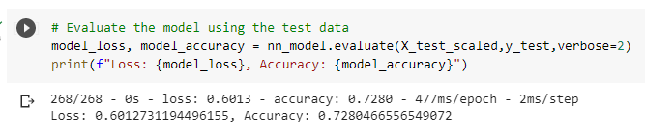

Model 3

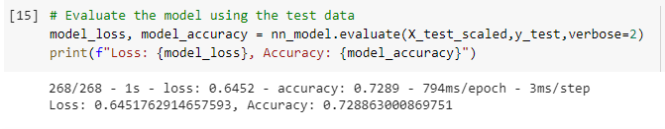

Final Model

